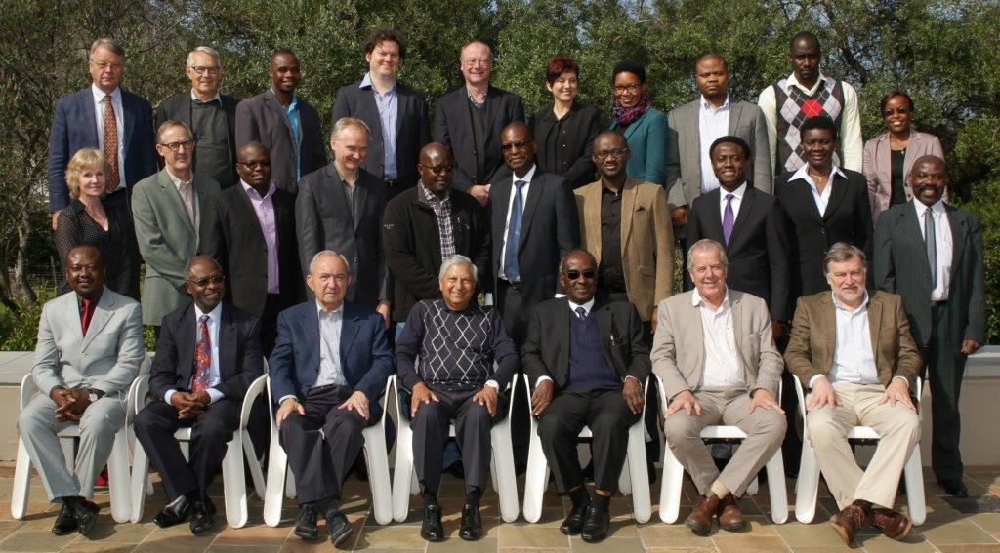

SASCA 2015 Group photo

Front row fltr: Mr Calixte Aristide Mbari; Prof Kwame Frimpong; Justice Richard Goldstone; Dr Bhadra Ranchod; Justice Samuel Kofi Date-Bah; Justice Johan Froneman; Prof Hendrik Geyer

Middle row: Miss Michelle Galloway; Prof Francois Venter; Dr Bnolo Dinokopila; Prof Magnus Killander; Mr Bugalo Maripe; Prof Kofi Quashigah; Mr Samson Itodo; Dr Horace Adjolohoun; Prof Ameze Guobadia; Prof Charles Fombad

Back row: Prof Andre Thomashausen; Prof Johann Groenewald; Mr Alois Madheken; Dr James Fowkes; Dr Arne Wulff; Prof Christa Rautenbach; Miss Mphathi Mutloane; Mr Phindile Ntliziywana; Mr Dickson Kahama; Miss Anneth Amin

